“English Course”

LAPORAN STUDI KASUS

MATA KULIAH COMP6360004 –

ALGORITHM AND PROGRAMMING

KELAS BB20


Oleh :
Reza Dwi Fanani | - | 2702327910
Ida Bagus Agung Rama Yoga | - | 2702348083
Calista Paramitha Chandra | - | 2702221841

Semester Ganjil 2023/2024

MALANG

BAB I

1.1 Penjelasan Tentang Studi Kasus yang Dipilih

Studi kasus kami adalah “English Course”, berikut adalah gambaran sekilas dari study case kami.

Adapun penjualan tersebut akan dicatat pada sebuah file yang bernama sales.txt.

File tersebut (DataSiswa.txt) akan berisi :

- Nomor Registrasi Siswa (ID)
- Nama Siswa
- Jenis Kursus (Beginner, Intermidiate, Advanced)
- Nilai Quiz (skala 0-100)
- Nilai Tugas (skala 0-100)
- Nilai Ujian (skala 0-100)
- Nilai Akhir Kursus (skala 0-100)
- Grade Akhir

Menu pada aplikasi ada menu entry, sort, & search data, seperti berikut:

- Entry: Data siswa kursus dan nilai siswa kursus (Quiz, Tugas, Ujian)

- Sort: Cetak laporan hasil kursus terurut berdasarkan ID, Grade terbaik, Grade paling sering dicapai beserta banyak siswa pada grade tersebut

- Search:Cari siswa dengan grade terbaik pada nilai akhir kursus, cari semua siswa yang mendapatkan grade tertentu.

1.2 Penjelasan tentang tampilan program

Berikut adalah tampilan di menu utama:

WELCOME TO ENGLISH SCORE CALCULATION MANAGEMENT
This is made to suffice out final project assignement in Algorithm and Programming Study Course

HERE IS A LIST OF WHAT WE CAN DO FOR YOU:

- Entry

- Sort

- Search

- Exit

Menu Entry:
Here are what you could do:
- Add New Student
- Edit Student Data
- Delete Student Data
- Back to Main Menu
Enter your Option:

Menu Sort:

Please choose your preferred sorting method:

- Sort data by student ID
- Sort data by Best Grade
- Sort Data by Mode Grade
- Sort Data by Name
Enter your sorting option:

(Exclusive for option other than 2 and 3):
Please select the sorting order:
- Ascending
- Descending
Enter your option:
(user diminta memilih jenis sorting dan sistem sorting baik ascending maupun descending.)

Menu Search:
Please Choose your Searching Way:
- Search by Student ID
- Search by Name
- Search by Final Grade
- Back to Main Menu

1.3 Semua Fitur Program serta Penjelasan Masing-masing Fitur

Fitur yang terdapat pada main menu sebagai berikut:

Entry, sort search dan print data yang sudah masuk.

Entry

Meminta pengguna untuk memasukkan informasi seperti ID siswa, nama, level kursus, skor dari beberapa ujian (quiz, tugas, ujian), dan menghitung skor akhir serta menentukan grade siswa berdasarkan skor tersebut.
Melakukan validasi untuk memastikan bahwa input yang dimasukkan sesuai dengan kriteria yang ditetapkan, seperti membatasi nilai skor dari 0 hingga 100 dan memastikan level kursus yang dimasukkan adalah salah satu dari tiga level yang diterima (Beginner, Intermediate, Advanced).
Menyimpan data siswa yang baru dimasukkan ke dalam file eksternal ("DataSiswa.txt") untuk penyimpanan dan manajemen data.

Sort

sortBy(): Menyajikan sub-menu yang meminta pengguna untuk memilih jenis pengurutan yang diinginkan (berdasarkan ID siswa, skor terbaik, atau mode grade).
quicksort(): Algoritma pengurutan cepat yang digunakan untuk mengurutkan data siswa berdasarkan pilihan pengguna.
**partition(), compareByID(), compareByBestGrade(), compareByModeGrade(): Fungsi-fungsi pendukung dalam proses pengurutan untuk membandingkan elemen-elemen dalam data siswa.

Search

**searchFinalGrade(), searchName(), searchID(): Menerima input dari pengguna berupa kriteria pencarian (grade akhir, nama, atau ID siswa) dan menggunakan metode pencarian yang berbeda-beda (seperti interpolasi atau binary search) untuk menemukan siswa yang sesuai dengan kriteria yang dimasukkan.
Setelah menemukan siswa yang sesuai, fungsi-fungsi ini memberikan informasi tentang lokasi siswa tersebut dalam data (seperti indeks dalam array) dan menampilkan informasi tersebut kepada pengguna.

1.4 Penjelasan semua proses dalam program

1.main():

Fungsi utama yang mengatur alur program.
Memuat data dari file "DataSiswa.txt" jika ada.
Menampilkan menu dan meminta input pengguna untuk memilih opsi.
Memanggil fungsi-fungsi terkait berdasarkan pilihan pengguna.

2.menuDisplay():
Menampilkan menu utama dengan opsi untuk entry, pengurutan, pencarian, dan keluar.

3.read() dan write():
read(): Membaca data siswa dari file "DataSiswa.txt" ke dalam array students.
write(): Menulis data siswa dari array students ke file "DataSiswa.txt".

4.entryFunction():
Memungkinkan pengguna untuk memasukkan data siswa baru.
Melakukan validasi untuk memastikan data yang dimasukkan sesuai dengan kriteria yang ditetapkan.

5.Fungsi Sorting (sortBy(), quicksort(), partition(), compareByID(), compareByBestGrade(), compareByModeGrade()):
sortBy(): Meminta pengguna untuk memilih jenis pengurutan (ID, Best Grade, Mode Grade) dan urutan (ascend/descend).
quicksort(): Algoritma pengurutan cepat yang digunakan untuk mengurutkan data siswa berdasarkan pilihan pengguna.
partition(): Bagian dari algoritma quicksort yang mempartisi data.
**compareByID(), compareByBestGrade(), compareByModeGrade(): Fungsi perbandingan yang digunakan dalam pengurutan.

6.Fungsi Pencarian (searchFinalGrade(), searchName(), searchID()):
**searchFinalGrade(), searchName(), searchID(): Melakukan pencarian berdasarkan grade, nama, atau ID siswa dengan menggunakan metode pencarian yang berbeda-beda (interpolasi, binary search).

7.Fungsi displayData():
Menampilkan data siswa yang ada dalam file.

8.Validasi fungsi (validateCourseLevel(), validateScore())
Memastikan input sesuai dengan kriteria yang ditentukan.
BAB II

SCREENSHOT PROGRAM:

Menu Utama
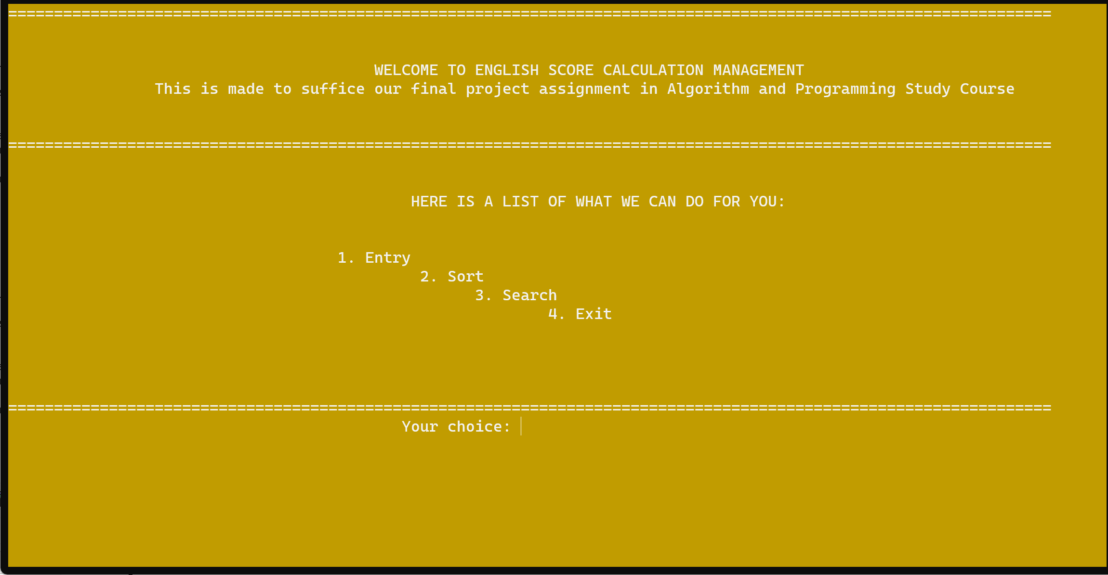

INPUT: 1


INPUT: 2
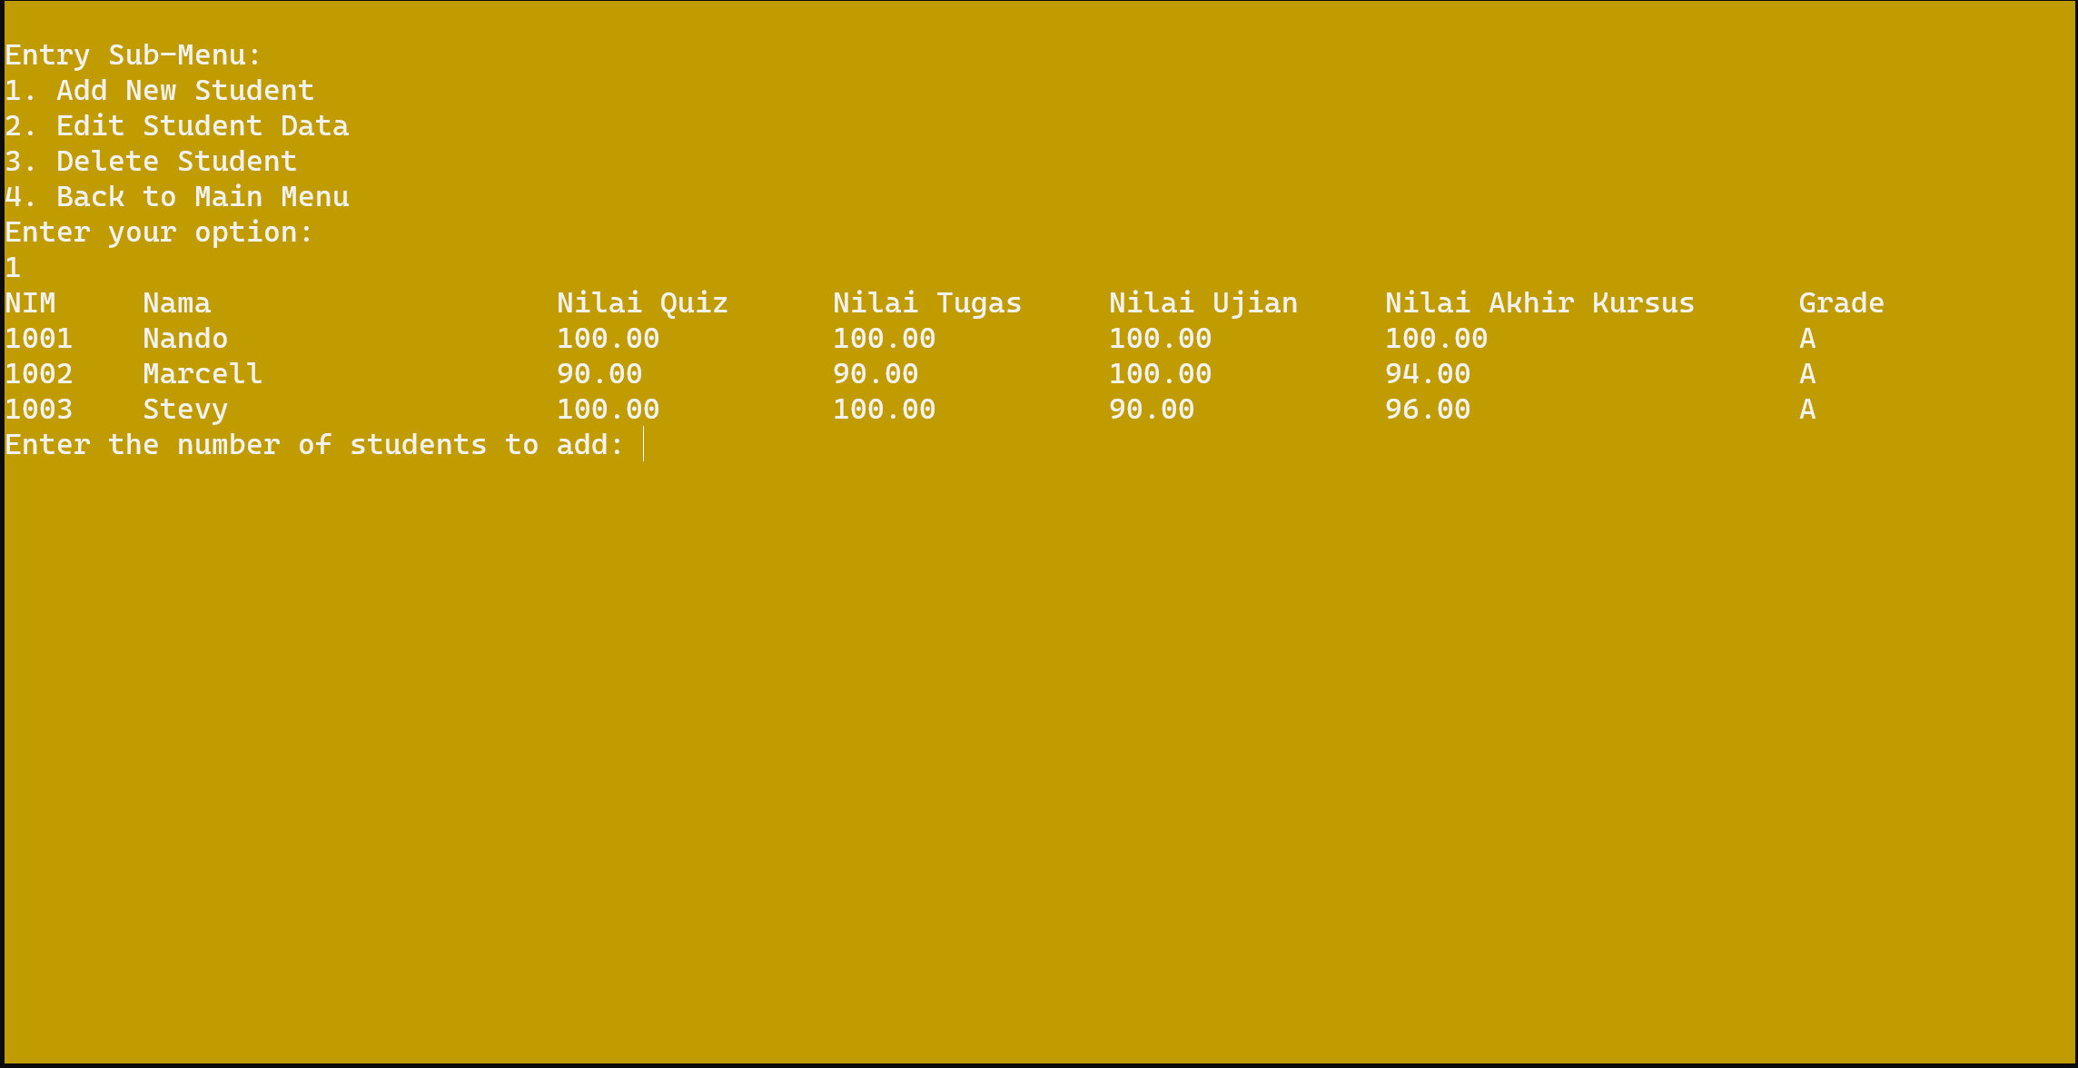

INPUT: 3
Tekan 1 untuk menambahkan Mahasiswa

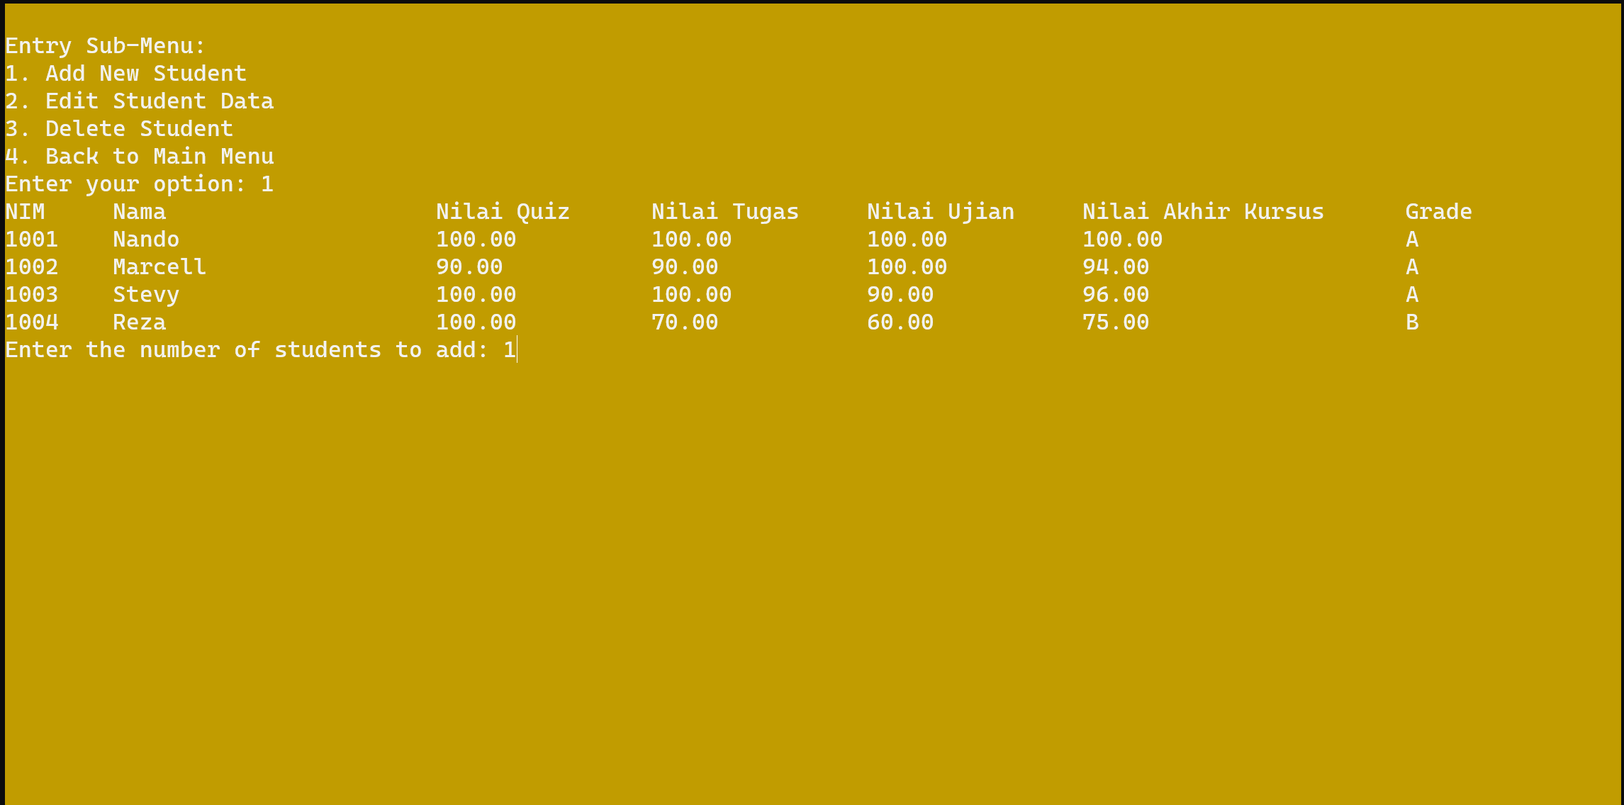

Masukan Nilai-Nilai mahasiswa untuk di tambahkan
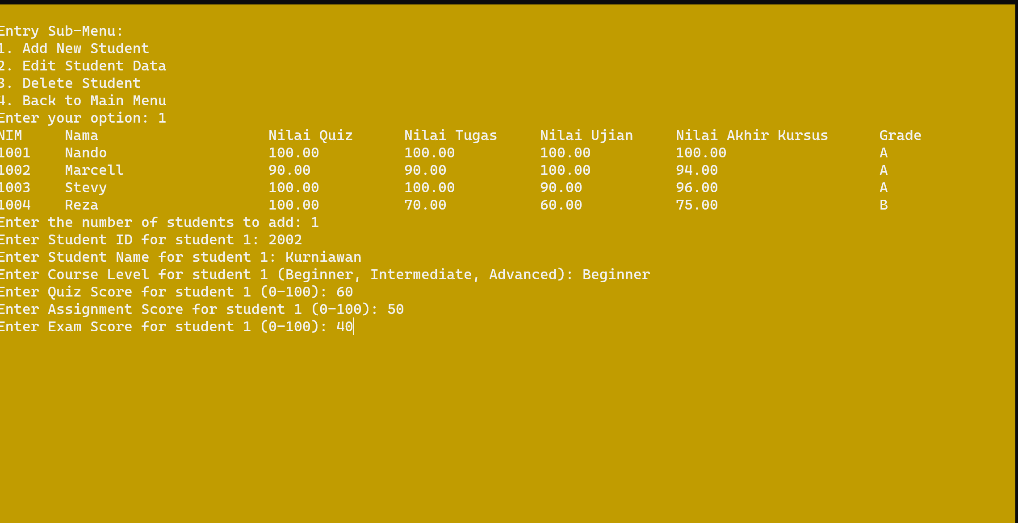

Nama Mahasiswa Berhasil di tambahkan
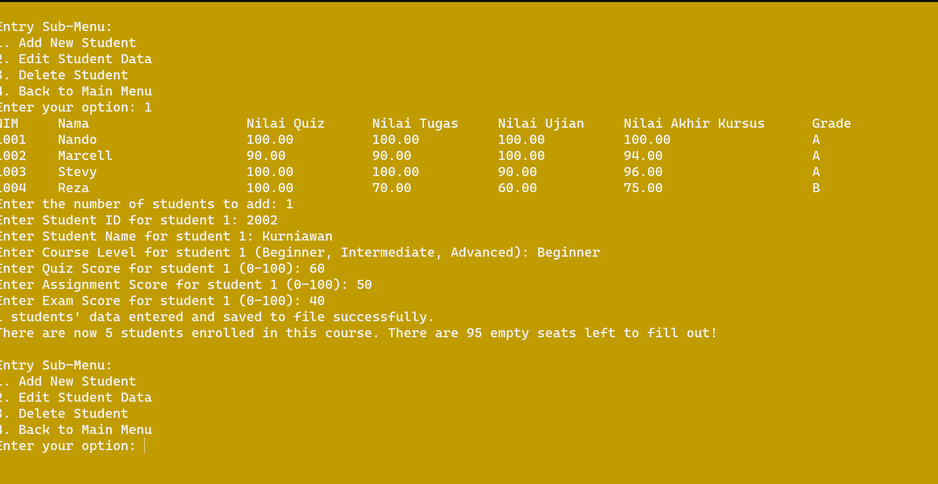

Tekan 2 untuk edit data Mahasiswa
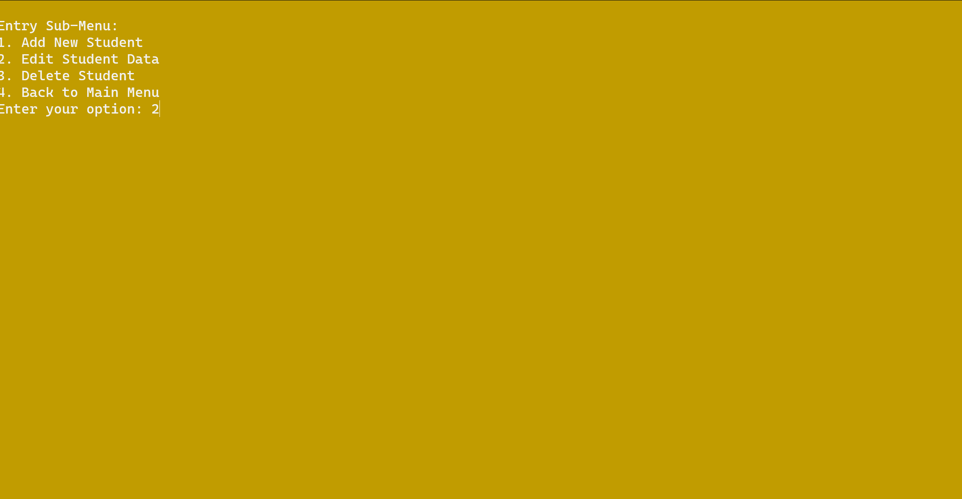

Data berhasil di ID berhasil di Ubah
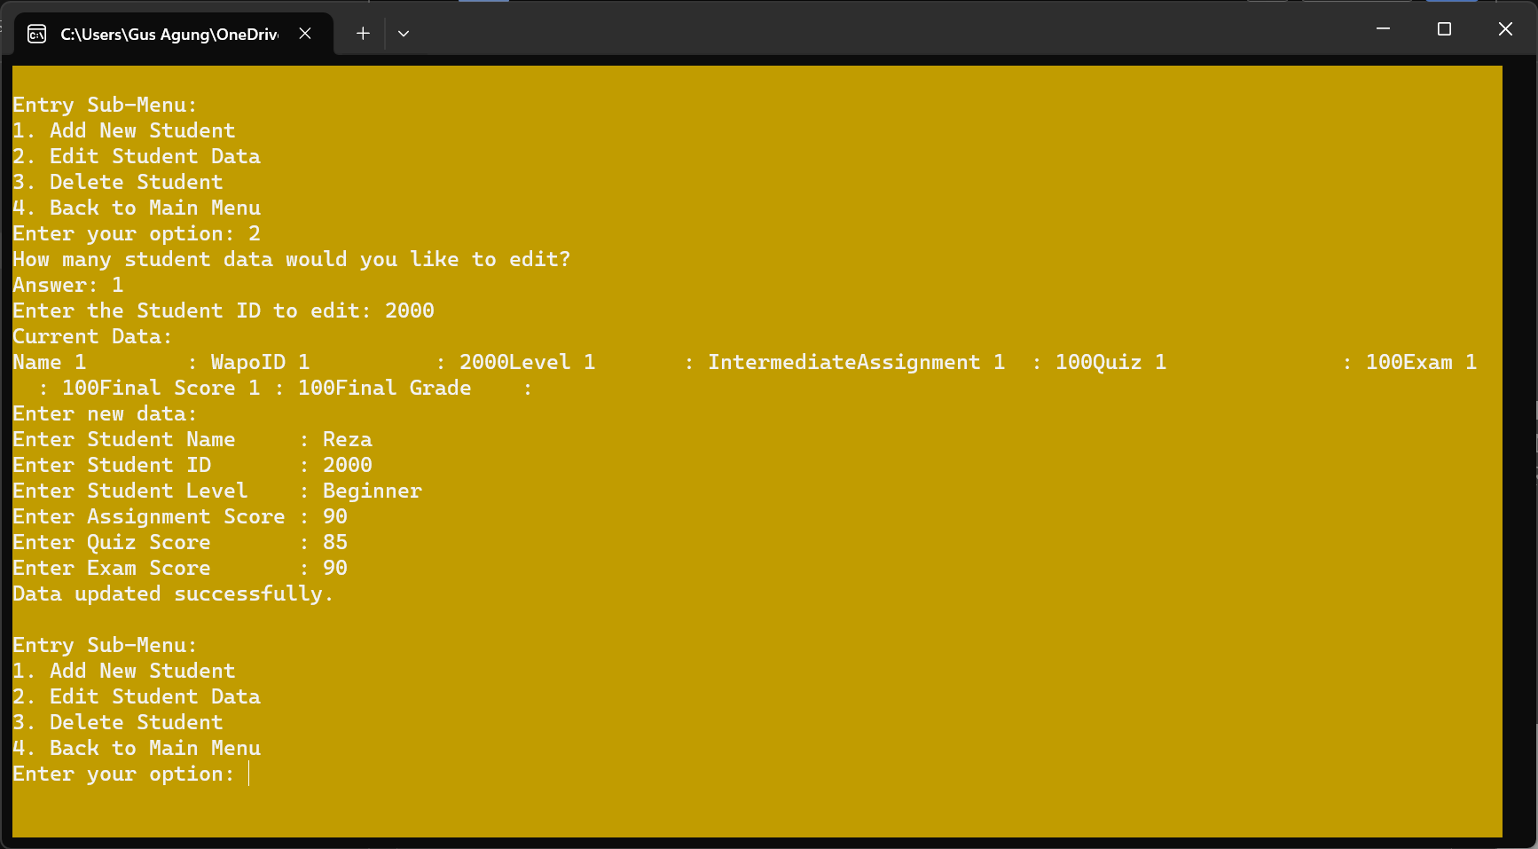

Tekan 3 untuk menghapus Nilai Mahasiswa
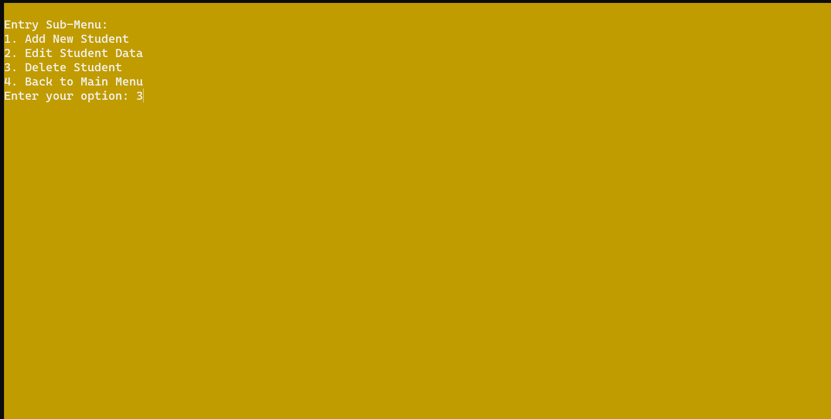

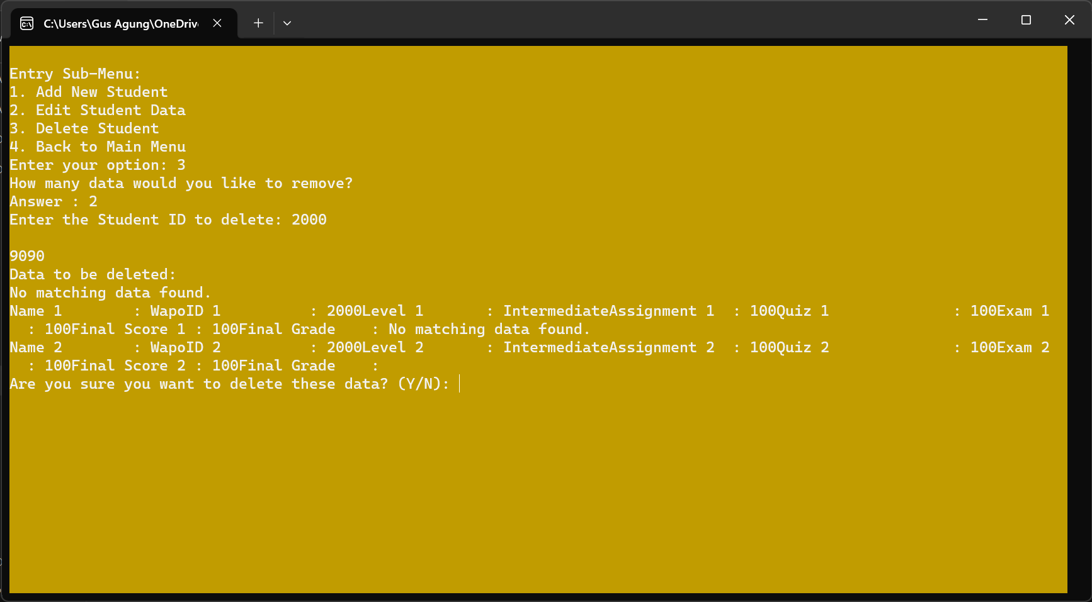

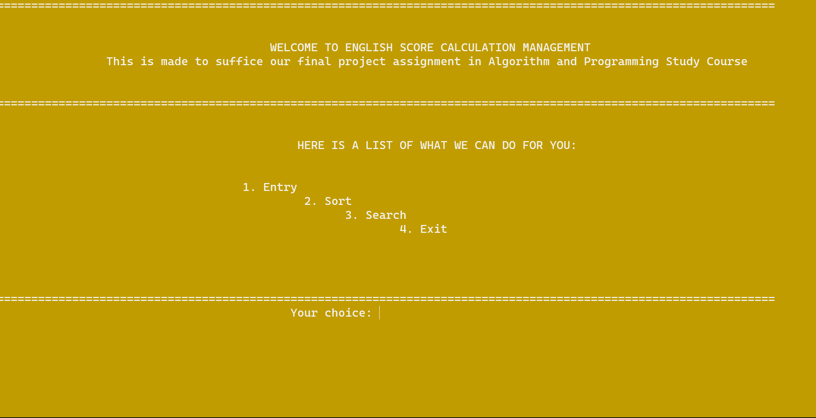

INPUT: 0 (untuk kembali ke menu utama)

SORTING

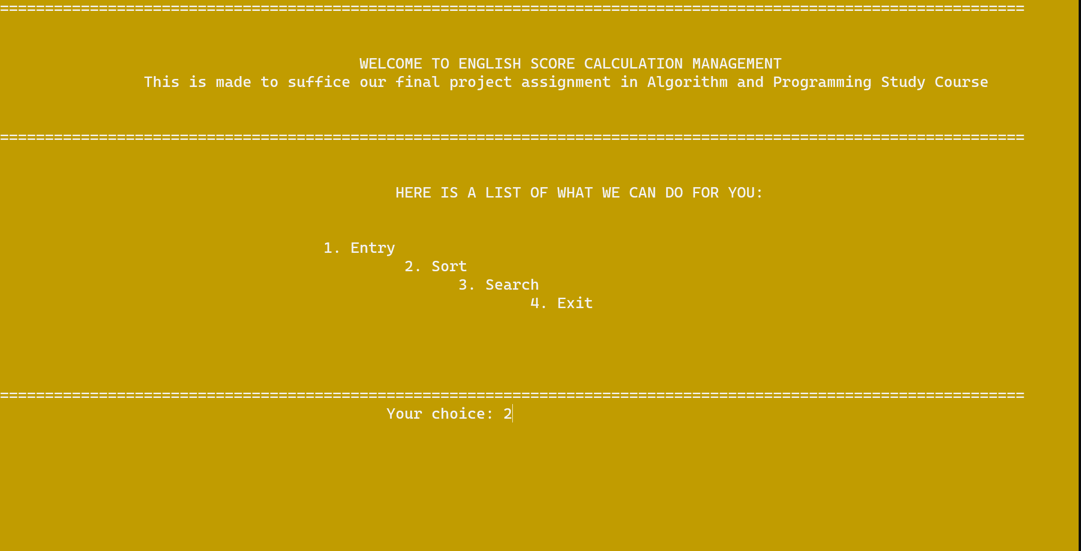

INPUT: 2

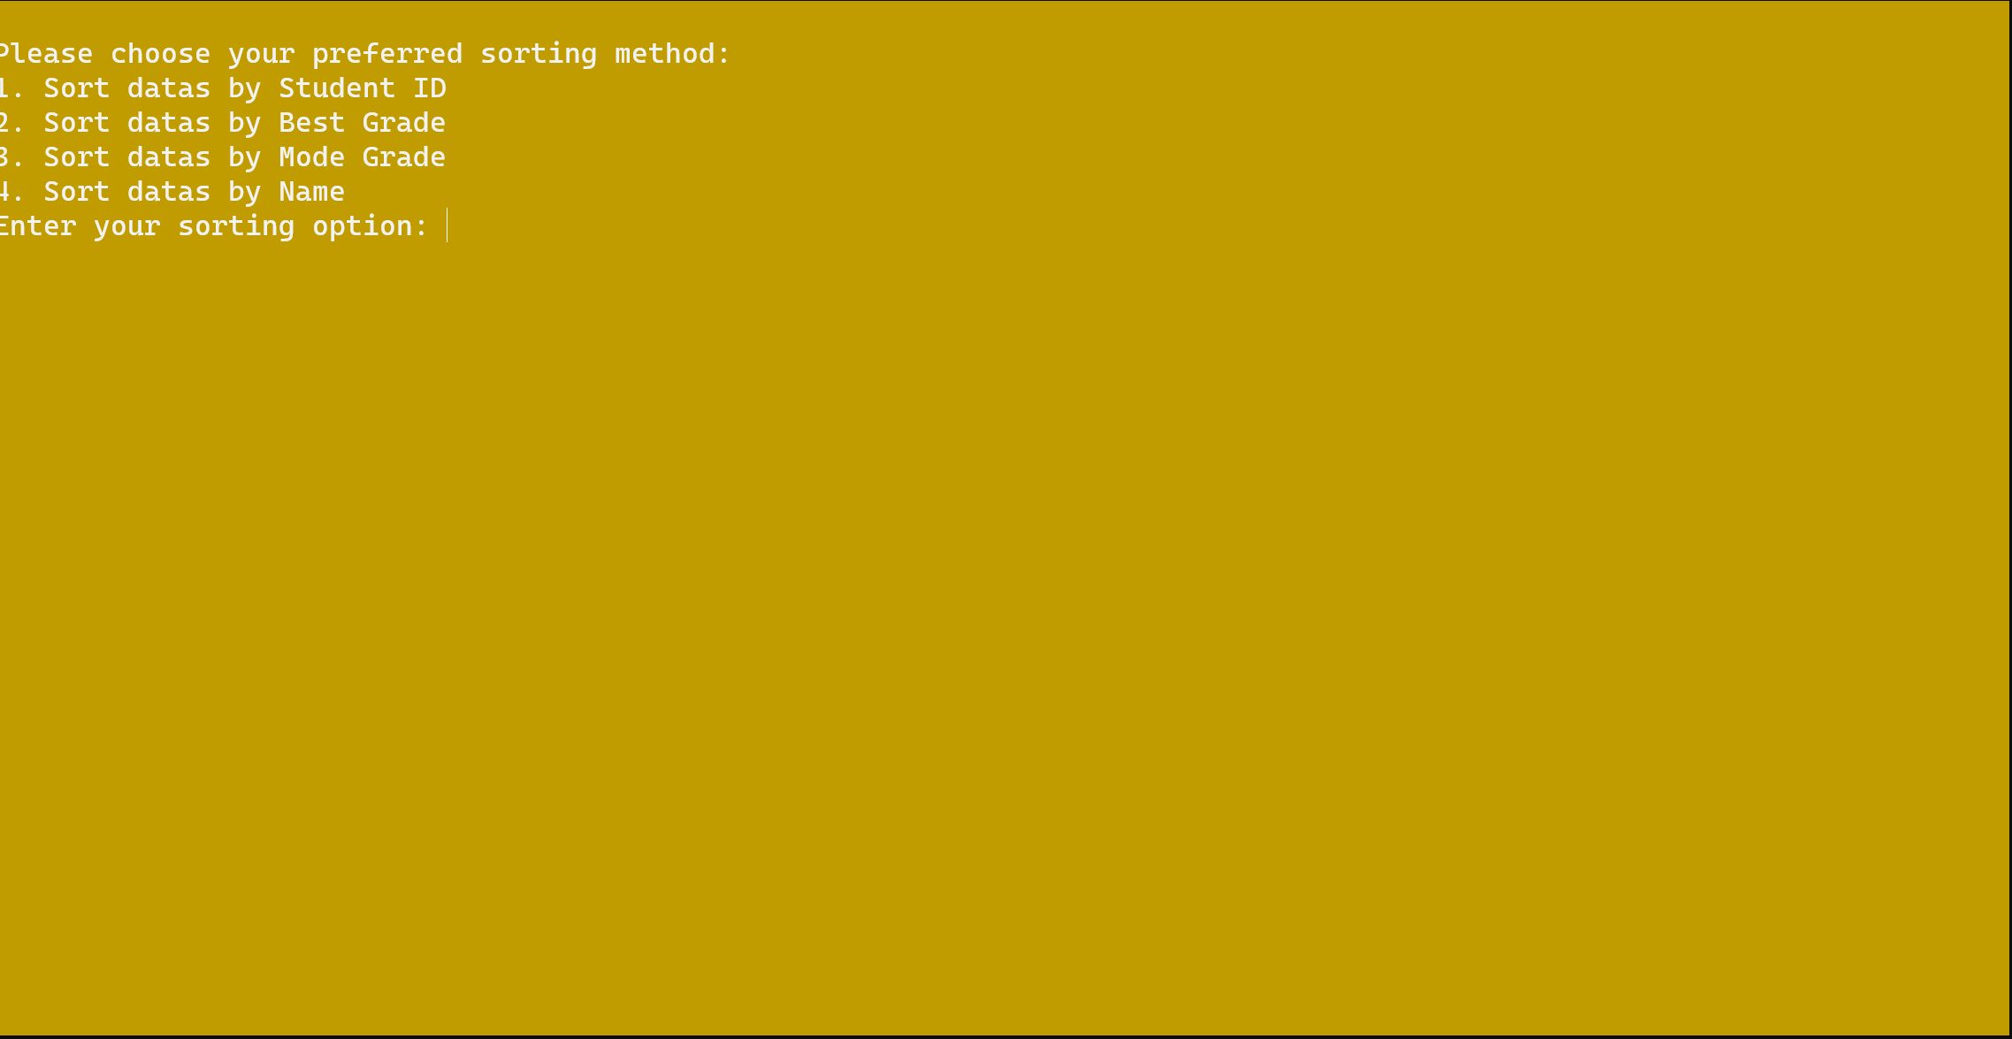
Input :1

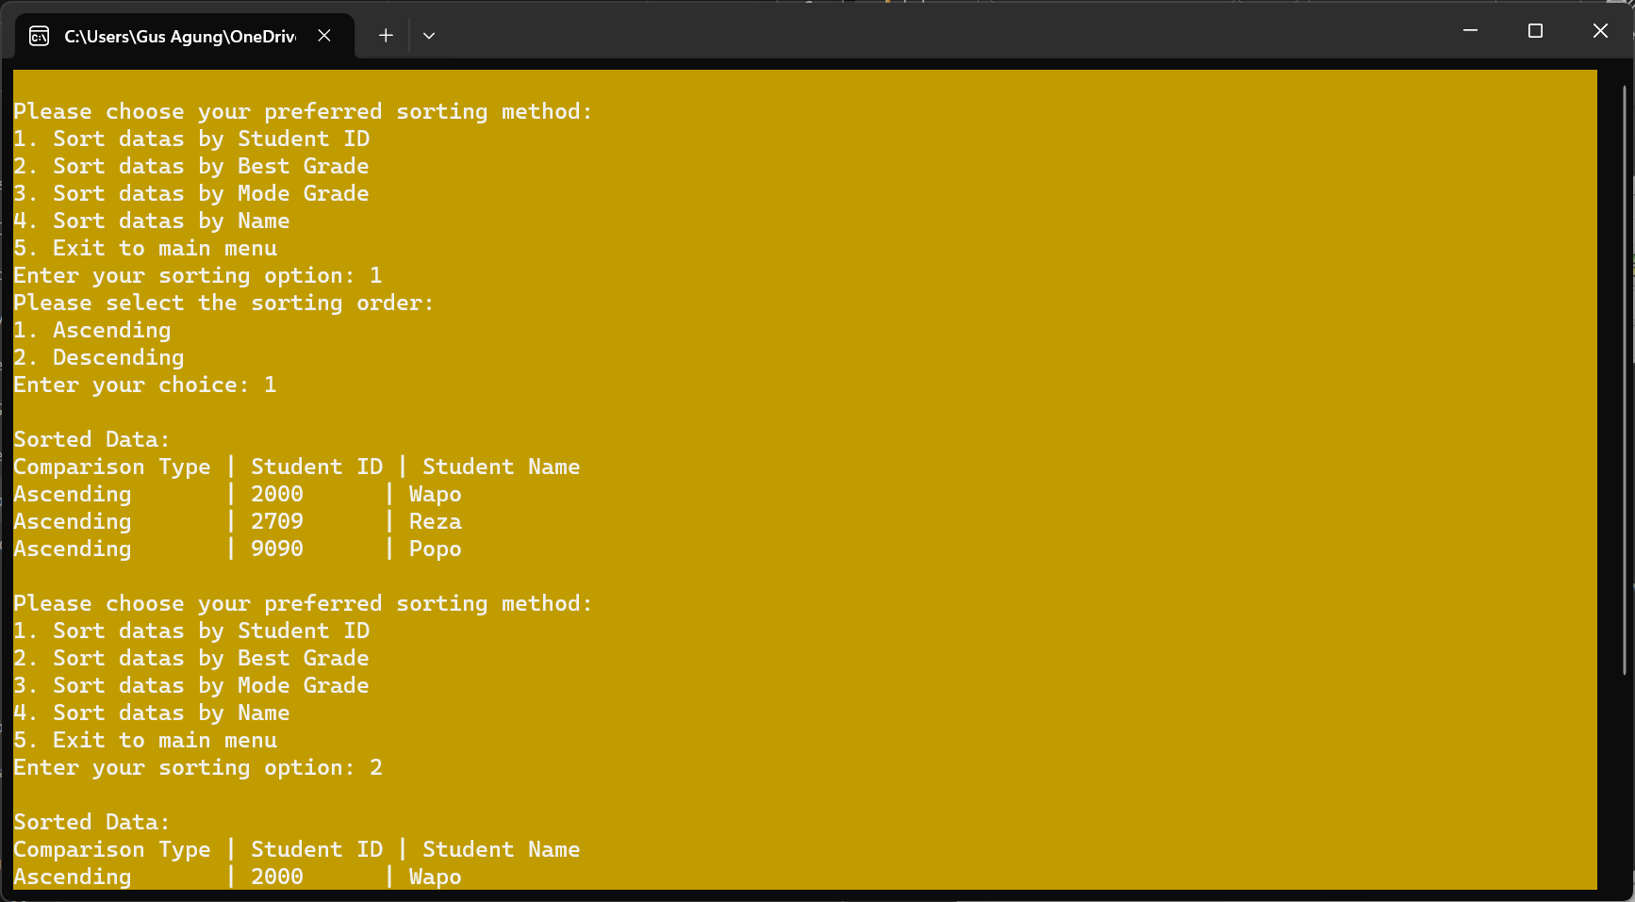
Input :1
Asending dan menampilkann data data ID Mahasiswa

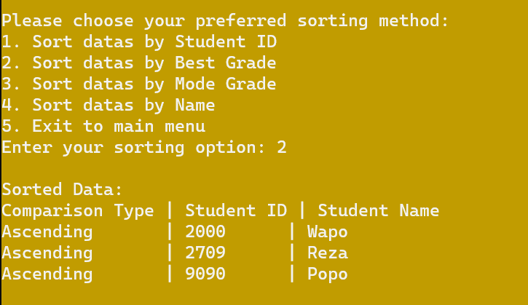
Input 2:
Menampilkan Grade atau Nilai tertinggi

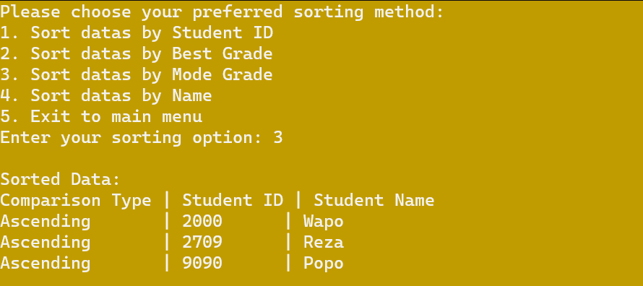
Mengurutkan Kelas dari Mahasiswa

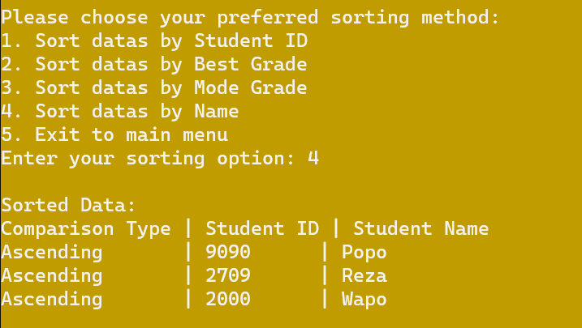
Menampilkan Nama sesuai Variable

Search

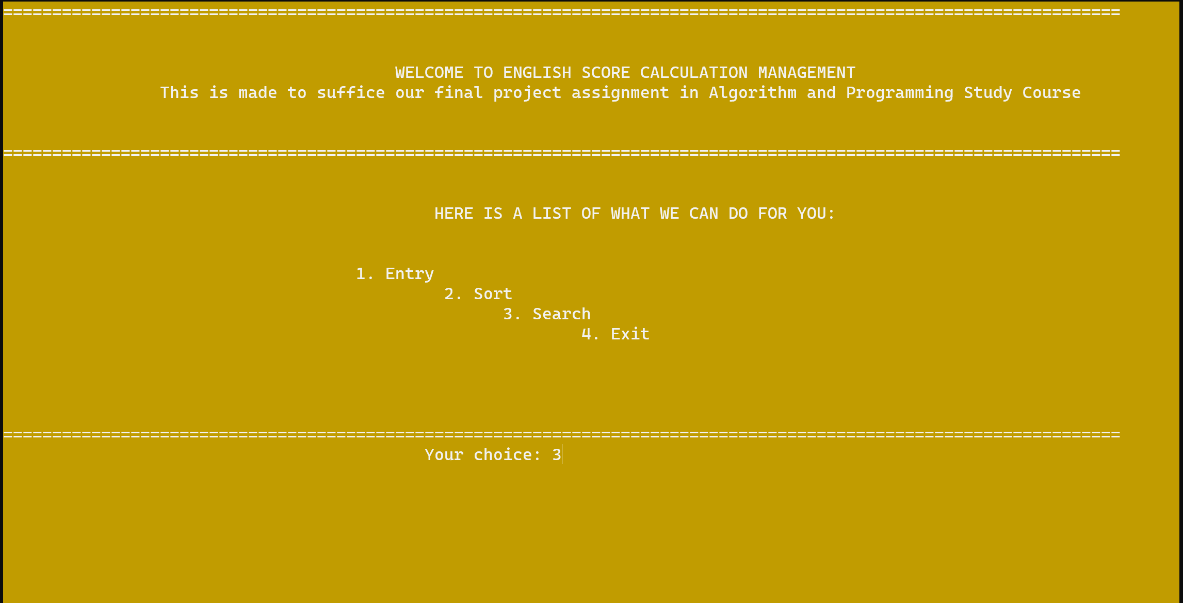

INPUT :3

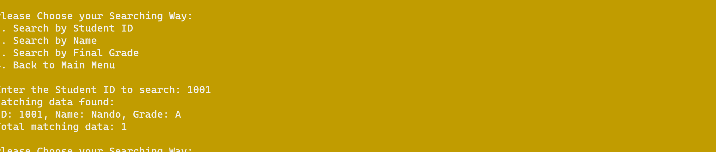

Input 1 Masukan ID Mahasiswa dan hasilnya akan mengeluarkan Grade

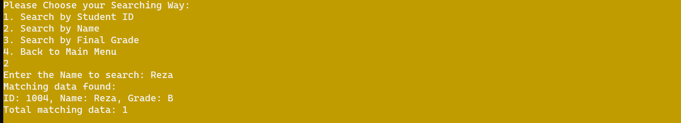

Input 2
Masukan Nama Mahasiswa dan hasilnya Menampilkan Nilai dan Grade dari Mahasiswa

SOURCE CODE PROGRAM
#include <stdio.h>
#include <stdlib.h>
#include <string.h>
#include <windows.h>

#define MAX_STUDENTS 100
//the max of student the program can manage = 100 (constant)
#define MAX_NAME_LENGTH 50

typedef struct {
int id;
char name[MAX_NAME_LENGTH];
char courseLevel[15];
int quiz;
int assignment;
int exam;
int score;
char grade;
} Student;

//function prototype (declarations)
void menuDisplay();
void read(Student students[], int *studentCount);
void write(Student students[], int studentCount);
void displayData();

//function involved in entry
void entry(Student students[], int *studentCount);
void validateCourseLevel(char *courseLevel);
void validateScore(int *score);
void deleteData(Student students[], int *studentCount);
void edit(Student students[], int studentCount);

//function involved in sorting
void sortBy(Student students[], int numStudents, int ascending, int (*compare)(const void *, const void *));
void quicksort(Student students[], int low, int high, int (*compare)(const void *, const void *));
int partition(Student students[], int low, int high, int (*compare)(const void *, const void *));
int compareByID(const void *a, const void *b);
int compareByBestGrade(const void *a, const void *b);
int compareByModeGrade(const void *a, const void *b);
int compareByName(const void *a, const void *b);

//function involved in searching
void displayResults(Student students[], int indices[], int count);
int searchFinalGrade(Student students[], int studentCount, char searchKey, int indices[], int maxIndices);
int searchName(Student students[], int studentCount, const char *searchKey, int indices[], int maxIndices);
int searchID(Student students[], int studentCount, int searchKey, int indices[], int maxIndices);

int main() {
system("COLOR 6F");
Student students[MAX_STUDENTS];
int studentCount = 0;

//Load existing data from the file so that the program can manage them
read(students, &studentCount);

int choice;
//Option variable for the sub-menu
int entryOpt, sortOption, sortOrder, searchOpt, keyID, indices[MAX_STUDENTS];
//Searchkey
char keyName[MAX_NAME_LENGTH], keyGrade;
// Determine comparison function based on user choice
int (*compareFunction)(const void *, const void *);

do {
menuDisplay();
printf("\t\t\t\t\t Your choice: ");
scanf("%d", &choice);
printf("\n\n\n-------------------------------------------------------------------------------------------\n");
system("cls");

switch (choice) {
case 1:
//This is the option that allows user to input new student datas

do{
//Display entry sub-menu:
printf("\nEntry Sub-Menu:\n");
printf("1. Add New Student\n");
printf("2. Edit Student Data\n");
printf("3. Delete Student\n");
printf("4. Back to Main Menu\n");
printf("Enter your option: ");
scanf("%d", &entryOpt);

switch (entryOpt) {
case 1:
entry(students, &studentCount);
break;
case 2:
edit(students, studentCount);
break;
case 3:
deleteData(students, &studentCount);
break;
case 4: // Back to the main menu
break;
default:
printf("Invalid input. Please enter a valid option.\n");
}
} while (entryOpt != 4);

break;

case 2:
// This is the option that prompts the program to sort the data

do{
// Display sorting sub-menu
printf("\nPlease choose your preferred sorting method:\n");
printf("1. Sort datas by Student ID\n");
printf("2. Sort datas by Best Grade\n");
printf("3. Sort datas by Mode Grade\n");
printf("4. Sort datas by Name\n");
printf("5. Exit to main menu");
printf("Enter your sorting option: ");
scanf("%d", &sortOption);

//Sorting sub-menu selection branch
switch (sortOption) {
case 1:
compareFunction = compareByID;
break;
case 2:
compareFunction = compareByBestGrade;
break;
case 3:
compareFunction = compareByModeGrade;
break;
case 4:
compareFunction = compareByName;
case 5:
break;
default:
printf("Invalid sorting option. Returning to main menu.\n");
break;
}

if (sortOption == 2 || sortOption == 3 || sortOption == 4) {
// For 'best grade' and 'mode grade', always sort in descending order
sortBy(students, studentCount, 1, compareFunction);
} else {
// For other cases, prompt the user for the order
printf("Please select the sorting order:\n");
printf("1. Ascending\n");
printf("2. Descending\n");
printf("Enter your choice: ");
scanf("%d", &sortOrder);

//Perform the sorting
sortBy(students, studentCount, sortOrder, compareFunction);
write(students, studentCount); //save the progress of data processing
}
} while (sortOption >= 1 && sortOption <= 4);
break;

case 3:
// This is the option that allows user to search a certain student or
//a group of students.

do{
// Display search menu
printf("\nPlease Choose your Searching Way:\n");
printf("1. Search by Student ID\n");
printf("2. Search by Name\n");
printf("3. Search by Final Grade\n");
printf("4. Back to Main Menu\n");
scanf("%d", &searchOpt);

// Perform search based on user choice
switch (searchOpt) {
case 1: {
printf("Enter the Student ID to search: ");
scanf("%d", &keyID);
int idSearchResult = searchID(students, studentCount, keyID, indices, MAX_STUDENTS);
break;
}

case 2: {
printf("Enter the Name to search: ");
scanf("%s", keyName);
int nameSearchResult = searchName(students, studentCount, keyName, indices, MAX_STUDENTS);
break;
}

case 3: {
printf("Enter the Final Grade to search: ");
scanf(" %c", &keyGrade);
int gradeSearchResult = searchFinalGrade(students, studentCount, keyGrade, indices, MAX_STUDENTS);
break;
}

case 4: {
//Back to Main Menu
break;
}

default:
printf("Invalid choice. Choose between number 1 to number 4.\n");
break;
}
} while (searchOpt >= 1 && searchOpt <= 3);
break;

case 4:
// Exit the Program (Bubhyee)
write(students, studentCount);
printf("Your Data has been Updated. Now Exiting program.\n");
break;
default:
printf("Invalid choice. Please enter a valid option.\n");
}
} while (choice != 4);

return 0;
}

void read(Student students[], int *studentCount) {
FILE *fpoint = fopen("DataSiswa.txt", "r");

if (fpoint == NULL) {
printf("File not found. Starting with an empty dataset.\n");
return;
}

while (fscanf(fpoint, "%d %s %s %d %d %d %d %c",
&students[*studentCount].id,
students[*studentCount].name,
students[*studentCount].courseLevel,
&students[*studentCount].quiz,
&students[*studentCount].assignment,
&students[*studentCount].exam,
&students[*studentCount].score,
&students[*studentCount].grade) == 8) {
(*studentCount)++;
if (*studentCount == MAX_STUDENTS) {
break; //to Avoid exceeding array size
}
}

fclose(fpoint);
}

void displayData() {
FILE *file = fopen("DataSiswa.txt", "r");

// Memeriksa apakah file berhasil dibuka
if (file == NULL) {
printf("Gagal membuka file.\n");
return;
}

// Membaca dan menampilkan data dari file
int nim;
char nama[50];
char tipe[50];
float nq, nt, nu, nak;
char grade;

printf("NIM\tNama\t\t\tNilai Quiz\tNilai Tugas\tNilai Ujian\tNilai Akhir Kursus\tGrade\n");

while (fscanf(file, "%d %s %s %f %f %f %f %c", &nim, nama, tipe, &nq, &nt, &nu, &nak, &grade) == 8) {
printf("%d\t%s\t\t\t%.2f\t\t%.2f\t\t%.2f\t\t%.2f\t\t\t%c\n", nim, nama, nq, nt, nu, nak, grade);
}

// Menutup file setelah selesai membaca
fclose(file);
}

// Function to write data to a file, for saving purposes
void write(Student students[], int studentCount) {
FILE *fpoint = fopen("DataSiswa.txt", "w");

if (fpoint == NULL) {
printf("Error opening file for writing.\n");
return;
}

for (int i = 0; i < studentCount; i++) {
fprintf(fpoint, "%d %s %s %d %d %d %d %c\n",
students[i].id,
students[i].name,
students[i].courseLevel,
students[i].quiz,
students[i].assignment,
students[i].exam,
students[i].score,
students[i].grade);
}

fclose(fpoint);
}

//Below is the main menu contain, stored in menuDisplay function
void menuDisplay(){
printf("==================================================================================================================\n");
printf("\n\n\t\t\t\t\tWELCOME TO ENGLISH SCORE CALCULATION MANAGEMENT");
printf("\n\t\tThis is made to suffice our final project assignment in Algorithm and Programming Study Course");
printf("\n\n\n==================================================================================================================\n");
printf("\n\n\t\t\t\t\t HERE IS A LIST OF WHAT WE CAN DO FOR YOU: \n");
printf("\n\n\t\t\t\t 1. Entry");
printf("\n\t\t\t\t\t 2. Sort\n");
printf("\t\t\t\t\t\t 3. Search\n");
printf("\t\t\t\t\t\t\t 4. Exit\n");
printf("\t\t\t\t\t\t\t\t \n");
printf("\n\n\n==================================================================================================================\n");
return;
}

//Validation Function so that the system will not accept any level other than Beginner, Intermediate, or Advanced
void validateCourseLevel(char *courseLevel) {
while (strcmp(courseLevel, "Beginner") != 0 &&
strcmp(courseLevel, "Intermediate") != 0 &&
strcmp(courseLevel, "Advanced") != 0) {
printf("The course level just now is invalid, please retry: ");
scanf("%s", courseLevel);
}
return;
}

//Validation Function so that the score range stays from 0 to 100.
void validateScore(int *score) {
while (*score < 0 || *score > 100) {
printf("The score just now is invalid, please retry: ");
scanf("%d", score);
}
return;
}

// Function to add a new student entry
void entry(Student students[], int *studentCount) {
displayData();
int Additional;

printf("Enter the number of students to add: ");
scanf("%d", &Additional);

if (*studentCount + Additional > MAX_STUDENTS) {
printf("Adding %d students would exceed the maximum limit.\n", Additional);
return;
}

FILE *fpoint = fopen("DataSiswa.txt", "a");
if (fpoint == NULL) {
printf("Error opening file for appending.\n");
return;
}

for (int i = 0; i < Additional; i++) {
printf("Enter Student ID for student %d: ", i + 1);
scanf("%d", &students[*studentCount + i].id);

printf("Enter Student Name for student %d: ", i + 1);
scanf("%s", students[*studentCount + i].name);

printf("Enter Course Level for student %d (Beginner, Intermediate, Advanced): ", i + 1);
scanf("%s", students[*studentCount + i].courseLevel);
validateCourseLevel(students[*studentCount + i].courseLevel);

printf("Enter Quiz Score for student %d (0-100): ", i + 1);
scanf("%d", &students[*studentCount + i].quiz);
validateScore(&students[*studentCount + i].quiz);

printf("Enter Assignment Score for student %d (0-100): ", i + 1);
scanf("%d", &students[*studentCount + i].assignment);
validateScore(&students[*studentCount + i].assignment);

printf("Enter Exam Score for student %d (0-100): ", i + 1);
scanf("%d", &students[*studentCount + i].exam);
validateScore(&students[*studentCount + i].exam);

// Calculate final score and determine final grade
students[*studentCount + i].score = ((30 * students[*studentCount + i].quiz) +
(30 * students[*studentCount + i].assignment) +
(40 * students[*studentCount + i].exam))/ 100;

if (students[*studentCount + i].score >= 85)
students[*studentCount + i].grade = 'A';
else if (students[*studentCount + i].score >= 70)
students[*studentCount + i].grade = 'B';
else if (students[*studentCount + i].score >= 60)
students[*studentCount + i].grade = 'C';
else if (students[*studentCount + i].score >= 50)
students[*studentCount + i].grade = 'D';
else
students[*studentCount + i].grade = 'E';

// Write to file
fprintf(fpoint, "%d %s %s %d %d %d %d %c\n",
students[*studentCount + i].id,
students[*studentCount + i].name,
students[*studentCount + i].courseLevel,
students[*studentCount + i].quiz,
students[*studentCount + i].assignment,
students[*studentCount + i].exam,
students[*studentCount + i].score,
students[*studentCount + i].grade);
}

fclose(fpoint);
printf("%d students' data entered and saved to file successfully.\n", Additional);
int empty = MAX_STUDENTS - (*studentCount + Additional);
if (empty < 100){
printf("There are now %d students enrolled in this course. There are %d empty seats left to fill out!\n",
*studentCount + Additional, empty);
} else printf("Yay!! Our program now has reached the maximum capacity!");
(*studentCount) += Additional;
return;
}

void edit(Student students[], int studentCount) {
int num, i, j;
printf("How many student data would you like to edit?\n");
printf("Answer: ");
scanf("%d", &num);
int editID[num];

//Prompt user to input the students IDs
for (i = 0; i < num; i++){
printf("Enter the Student ID to edit: ");
scanf("%d", &editID[i]);
}

// Find the index of the student with the given ID & Display the pre-edited data
printf("Current Data:\n");
for (j = 0; j < num; j++){
int index = (students, studentCount, editID[j], NULL, 0);

if (index != -1) {
// Display the current data for confirmation
printf("Name %d : %s", j+1, students[index].name);
printf("ID %d : %d", j+1, students[index].id);
printf("Level %d : %s", j+1, students[index].courseLevel);
printf("Assignment %d : %d", j+1, students[index].assignment);
printf("Quiz %d : %d", j+1, students[index].quiz);
printf("Exam %d : %d", j+1, students[index].exam);
printf("Final Score %d : %d", j+1, students[index].score);
printf("Final Grade : %c", j+1, students[index].grade);
} else {
printf("Student with ID %d not found.\n", editID[j]);
}
}

for (j = 0; j < num; j++){
int index = (students, studentCount, editID[j], NULL, 0);

if (index != -1){
// Prompt for new data
printf("\nEnter new data:\n");
printf("Enter Student Name : ");
scanf("%s", students[index].name);
printf("Enter Student ID : ");
scanf("%d", &students[index].id);
printf("Enter Student Level : ");
scanf("%s", students[index].courseLevel);
validateCourseLevel(students[index].courseLevel);
printf("Enter Assignment Score : ");
scanf("%d", &students[index].assignment);
validateScore(&students[index].assignment);
printf("Enter Quiz Score : ");
scanf("%d", &students[index].quiz);
validateScore(&students[index].quiz);
printf("Enter Exam Score : ");
scanf("%d", &students[index].exam);
validateScore(&students[index].exam);
}
}

printf("Data updated successfully.\n");

return;
}

void deleteData(Student students[], int *studentCount) {
int Dnum, i, j;

//prompt the user to input the amount of data to be deleted
printf("How many data would you like to remove?\n");
printf("Answer : ");
scanf("%d", &Dnum);
int deleteID[Dnum];

printf("Enter the Student ID to delete: ");
for (i = 0; i < Dnum; i++){
scanf("%d", &deleteID[i]);
}

printf("Data to be deleted:\n");
for (j = 0; j < Dnum; j++){
int index = searchID(students, *studentCount, deleteID[j], NULL, 0);

if (index != -1) {
// Display the current data for confirmation
printf("Name %d : %s", j+1, students[index].name);
printf("ID %d : %d", j+1, students[index].id);
printf("Level %d : %s", j+1, students[index].courseLevel);
printf("Assignment %d : %d", j+1, students[index].assignment);
printf("Quiz %d : %d", j+1, students[index].quiz);
printf("Exam %d : %d", j+1, students[index].exam);
printf("Final Score %d : %d", j+1, students[index].score);
printf("Final Grade : %c", j+1, students[index].grade);
} else {
printf("Student with ID %d not found.\n", deleteID[j]);
}
}

char confirm;
printf("\nAre you sure you want to delete these data? (Y/N): ");
scanf(" %c", &confirm);

for (j = 0; j < Dnum; j++){
int index = searchID(students, *studentCount, deleteID[j], NULL, 0);
if (index != -1) {
if (confirm == 'y' || confirm == 'Y') {
// Shift remaining elements to overwrite the deleted one
for (i = index; i < *studentCount - 1; i++) {
students[i] = students[i + 1];
}
// Decrement the number of students
(*studentCount)--;
printf("Data deleted successfully.\n");
} else if (confirm == 'N' || confirm == 'n'){
printf("Deletion canceled.\n");
} else printf("Your input is invalid");
} else {
printf("Student with ID %d not found.\n", deleteID);
}
}
return;
}

void quicksort(Student students[], int low, int high, int (*compare)(const void *, const void *)) {
if (low < high) {
int pivotIndex = partition(students, low, high, compare);

quicksort(students, low, pivotIndex - 1, compare);
quicksort(students, pivotIndex + 1, high, compare);
}

return;
}

int partition(Student students[], int low, int high, int (*compare)(const void *, const void *)) {
Student pivot = students[high];
int i = low - 1;

for (int j = low; j <= high - 1; j++) {
if (compare(&students[j], &pivot) < 0) {
i++;
// Swap students[i] and students[j]
Student temp = students[i];
students[i] = students[j];
students[j] = temp;
}
}

// Swap students[i + 1] and students[high]
Student temp = students[i + 1];
students[i + 1] = students[high];
students[high] = temp;

return i + 1;
}

int compareByID(const void *a, const void *b) {

return ((Student *)a)->id - ((Student *)b)->id;
}

int compareByBestGrade(const void *a, const void *b) {
int scoreA = ((Student *)a)->score;
int scoreB = ((Student *)b)->score;

return scoreB - scoreA; // Sort in descending order
}

int compareByModeGrade(const void *a, const void *b) {

return ((Student *)a)->grade - ((Student *)b)->grade;
}

int compareByName(const void *a, const void *b) {

return strcmp(((Student *)a)->name, ((Student *)b)->name);
}

void sortBy(Student students[], int studentCount, int ascending, int (*compare)(const void *, const void *)) {
// Perform quicksort
quicksort(students, 0, studentCount - 1, compare);

// Display sorted data
printf("\nSorted Data:\n");
printf("Comparison Type | Student ID | Student Name\n");
for (int i = 0; i < studentCount; i++) {
printf("%-16s| %-10d| %s\n", ascending ? "Ascending" : "Descending", students[i].id, students[i].name);
}

return;
}

void displaySearch(Student students[], int indices[], int count) {
if (count == 0) {
printf("No matching data found.\n");
} else {
printf("Matching data found:\n");
for (int i = 0; i < count; i++) {
printf("ID: %d, Name: %s, Grade: %c\n",
students[indices[i]].id, students[indices[i]].name, students[indices[i]].grade);
}
printf("Total matching data: %d\n", count);
}

return;
}

int searchFinalGrade(Student students[], int studentCount, char searchKey, int indices[], int maxIndices) {
int count = 0;

for (int i = 0; i < studentCount; i++) {
if (students[i].grade == searchKey) {
if (count < maxIndices) {
indices[count++] = i; // Store the index of the occurrence
}
}
}

displaySearch(students, indices, count);

return count; // Return the number of occurrences
}

int searchName(Student students[], int studentCount, const char *searchKey, int indices[], int maxIndices) {
int count = 0;

for (int i = 0; i < studentCount; i++) {
if (strcmp(students[i].name, searchKey) == 0) {
if (count < maxIndices) {
indices[count++] = i; // Store the index of the occurrence
}
}
}

displaySearch(students, indices, count);

return count; // Return the number of occurrences
}

int searchID(Student students[], int studentCount, int searchKey, int indices[], int maxIndices) {
int count = 0;

for (int i = 0; i < studentCount; i++) {
if (students[i].id == searchKey) {
if (count < maxIndices) {
indices[count++] = i; // Store the index of the occurrence
}
}
}

displaySearch(students, indices, count);

return count; // Return the number of occurrences
}

BAB III
Job desc anggota:

Reza Dwi Fanani: Coding bagian main khususnya display tabel, styling tampilan, Pembuat Kerangka Utama, Pembuat Data Siswa

Ida Bagus Agung Rama Yoga: Laporan, Codingan bagian sorting dan searching.
Calista Paramitha Chandra: Laporan, Pembuat Kerangka Utama, Coding bagian Main & File Processing, Mengembangkan kerangka fitur-fitur

